

Location Assessment
109 hawthorne crescent. West Drayton. Middlesex. Ub7 9pa

Contents page

- Area profile & accessibility of local services
- Socio – economics
- Crime rating
- Risk assessment & Risk management strategies
- Safeguarding
- Annex 2 Young people feedback

Introduction
All children, whether they are looked after by the state or their parents, need to feel safe in the area surrounding their home. Just as any parent would want to their child to live in a safe area so too will a corporate parent who places children in a children’s home. Recent public and media attention has focused on the physical environments of children’s homes. However, it is not always straightforward to define a ‘safe’ area. Whether a location is safe can change rapidly, and may depend on the vulnerabilities of particular children. Indeed some individual children may themselves heighten risks in an area if they have particularly risky behaviours.

A home may be located in an area with some local risks, and still be ‘safe’, if these are managed well, arrangements are made to keep children safe, and placement decisions take account of these risks. Consideration of risks in a local area, and what steps should be taken to mitigate these, should be part of the care planning and placement decision process. Placing social workers should be responsible for assessing local risks and making judgments about safe locations before placing the child. The availability of support and services in the local area (e.g. education, health, CAMHS), as well as risk factors, should be considered before the placement is made. There has been in the past a lack of clarity about who must take responsibility for ensuring children’s homes are located safely – including the roles of placing LAs, host LAs, LSCBs and providers themselves.

Role of the provider
Better equipping children’s home staff to make judgments about local risks, manage challenging behaviour, and keep children safe is an important element. Workforce training, support and knowledge is therefore critical to the success. It is acknowledged that there are limitations of mapping in capturing a ‘dynamic picture’ but considers that such mapping could play a useful part in the wider assessments of risk. The home’s location assessment should be kept under review and amended to take into account any new risks as these are identified. The annual update will need to be proportionate and will not usually need to be carried out at the level of the initial assessment. Ofsted inspectors may take into account the quality of an existing home’s manager’s location assessment when evaluating the effectiveness of the home’s approach to safeguarding and promoting children’s welfare. It will be essential to talk with children in the home’s care about the quality of life in the area to establish whether they feel safe and how to manage any risks they identify. Children will also be able to offer homes’ managers valuable insights about the quality of local services.
The Children’s Homes and Looked after Children (Miscellaneous Amendments) (England) Regulations 2013 introduced the following changes to the Children’s Homes Regulations 2001 and the Registration Regulations:
Regulation 31(1A) and (1B) of the Children’s Homes Regulations 2001 as amended introduced a requirement in January 2014 for providers or managers to:
- ensure that premises used for the purposes of a children’s home are appropriately and suitably located so that children cared for by the home are:
(a) effectively safeguarded, and
(b) able to access services to meet the needs identified in their care or placement plans;
- review the appropriateness and suitability of the location of the premises at
least once in every calendar year.

Location assessments will need to address two issues:
1. Safeguarding concerns
2. Accessibility of local services
It is important for the manager or a potential new provider to have a broad understanding of the characteristics of the area where a home is or may be located. Looked-after children placed in deprived areas, perhaps far away from the authority responsible for their care, may face disadvantage and lack opportunities to enjoy and achieve in these communities. The considerations a home manager will need to take into account, as they carry out a location assessment, may include:
• whether the location of the home influences the potential for an already vulnerable child to be a victim of crime, such as being targeted for sexual exploitation;
• whether there is a likelihood of children placed in the home becoming drawn into gang crime or anti-social behaviour in the local area;
• the suitability of the local neighbourhood as a location to care for children who may have already been victims of abuse and neglect; and
• whether there are environmental factors that would represent a hazard to children, such as locations near level crossings or busy roads.
Location assessments should also take into account any positive features in a local community that would offer benefits to children living in a children’s home. For example, assessments could include evidence about opportunities for children to participate in leisure, sporting or cultural activities, or links with services that could support the child’s ethnic or religious identity.

Area profile & accessibility of local services
Hawthorne Crescent in West Drayton is in the London region of England. The postcode is within the West Drayton ward/electoral division, which is in the constituency of Hayes and Harlington.

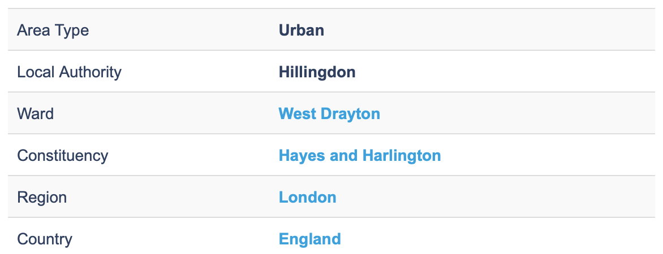
Basic Information

House Prices

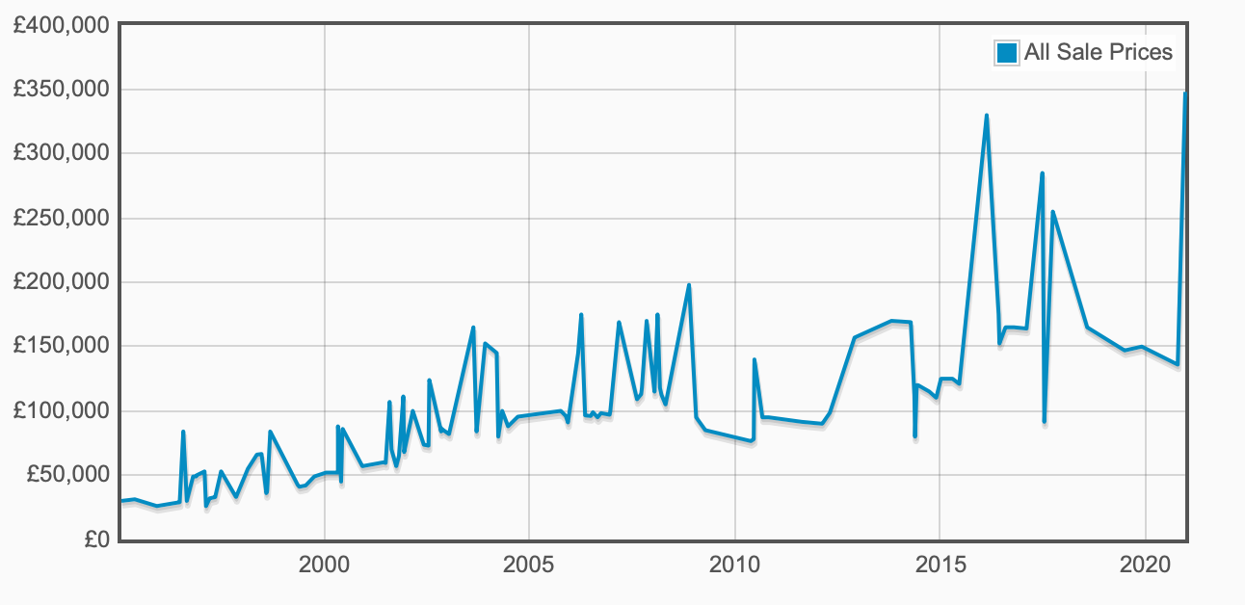
There have been120 property sales in Hawthorne Crescent since the beginning of 1995. The Highest Sale made was £348,000 on 18th December 2020.

Housing Tenure
The area containing Hawthorne Crescent, West Drayton contains a higher-than-average level of social housing - 25% of household spaces. This contrasts with the national average of just over 18%.
Culture
Hawthorne Crescent, West Drayton can be considered more ethnically diverse than the UK average. As whole, the UK population claims itself as approximately 86% white, with residents of this area being 62% so.

As a country with a diverse population, the UK is home to other sizable ethnic groups, with mixed ethnicity (2.1%), Indian (2.4%) and Pakistani (1.9%) being the largest groups reported.

Accessibility of local services
Hawthorne crescent, West Drayton is located in Hounslow, the London Borough of Hounslow is a west London based London borough that generates a section of outside of London. The borough comes from the central London area in the east side to the border with west side Surrey and it covers Isleworth, Brentford, and Chiswick in addition to the original Hounslow area.

Local Services Within 3 miles of Northfield Road
- Primary School: West Drayton Academy: West Drayton Academy, Kingston Lane, West Drayton, UB7 9EA
- Secondary School: Park Academy West London: Park Academy West London, Park View Road, Hillingdon, UB8 3GA
- Tube Station: Heathrow Terminals 2 & 3 Tube Station: Heathrow Terminals 1, 2, 3, London Underground Ltd., Wellington Road, Hounslow, Middlesex, TW6 1JH
- Railway Station: West Drayton Railway Station: West Drayton station, Station Approach, West Drayton, Greater London, UB7 9DY
- Hospitals: The Riverside Centre, Uxbridge: The Riverside Centre, Pield Heath Road, Hillingdon Hospital, Uxbridge, UB8 3NN
- GP Practices: Yiewsley Family Practice, Yiewsley, West Drayton, Yiewsley Family Practice, Yiewsley Health Centre, 20 High Street, Yiewsley, West Drayton, UB7 7DP
- Dentist: West Drayton & Yiewsley Dental, Yiewsley: West Drayton & Yiewsley Dental, 2 Providence Road, West Drayton, Yiewsley, UB7 8HJ
- Optician: S H Harrold Ltd, Middlesex: S H Harrold Ltd,69 Station Road, West Drayton, Middlesex, UB7 7LR

Collection of publicly available local data
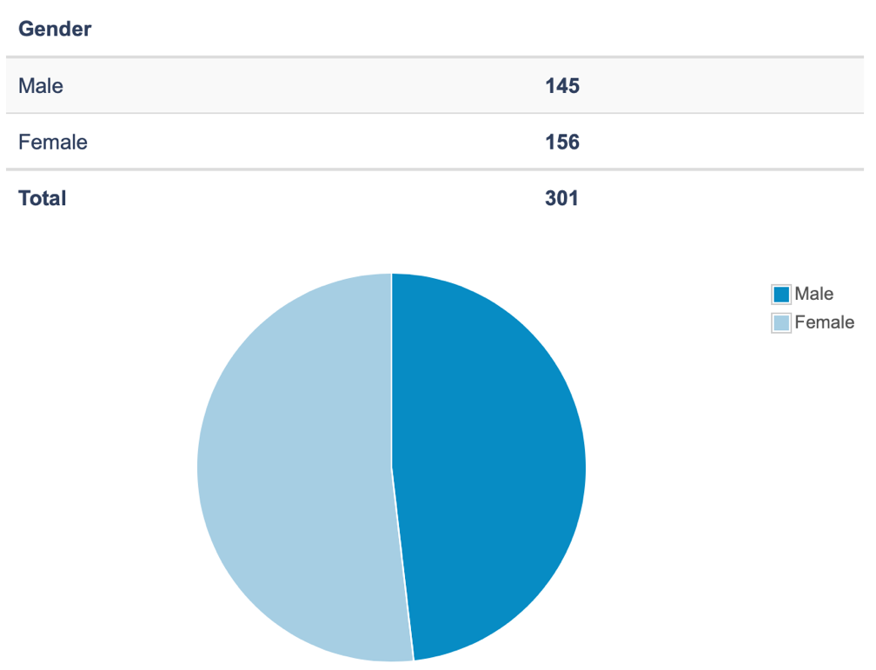
Across the UK, as a whole, the gender split is roughly equal at 49% male, 51% female. This address in Hayes and Harlington constituency is broadly in line with those figures, with 48% male.

Across the UK as a whole, the median age is 39. In general, inner city areas show high concentrations of people aged 18-30, suburbs show larger numbers of small children and adults aged 30-50, and rural and small towns are more popular with older workers and retirees. Many poorer areas lack a majority age group, which is due in part to the people in that area being constrained by circumstance rather than being able to choose where to retire, raise a family or grow up.

Hawthorne Crescent, West Drayton can be considered more ethnically diverse than the UK average. As whole, the UK population claims itself as approximately 86% white, with residents of this area being 62% so.
Crime Statistics

In total there have been found to be 140 crimes in July 2021 within half a mile of the centre of UB7 9PA.

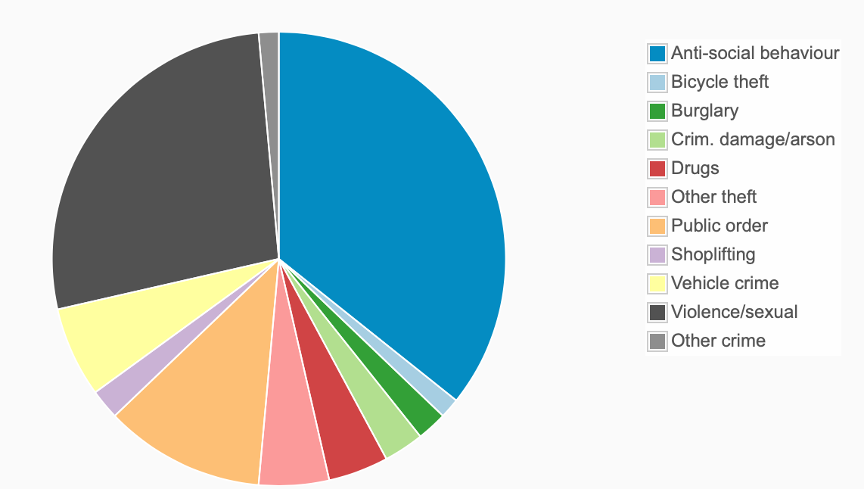

Safeguarding
There are no major concerns about the locality in which the home is based. There are low levels of crime, and the area is not highlighted by the local neighbourhood team or the MCSETO group as an area of concern.

There are no concerns of young people being drawn into gang crime or anti-social behaviour in the area as a result of the locality of the home. The home’s location does not increase the potential for children to be targeted for sexual exploitation, there are a number of take-aways and shops locally which research has evidenced have been hot spots for the grooming and exploitation of children, however, the area in which Northfield Road is located has not been an area of concern at the local multi-agency CSE, Missing and Trafficking operational group where this information is collated.

The overall risk of the location of the home is assessed as being low risk.

Consultation with appropriate local services
The Children’s home already has links within the local authority in order to consult about any local issues or individual issues with young people.
The key links for local services are detailed below and their responses to consultation on the location report.

Local Service | Key Individual and contact details
Safeguarding (including Missing from Home, CSE) | Child protection line 02085834515  childrenssocialcare@honslow.gov.uk
Crime | Hounslow police 02085771212
Local Probation / YOT | Phil Hopkins 02085836363 phil.hopkins@hounslow.gov.uk
Local School | Park Academy West London, UB8 3GA
Local Health Services | HESTON PRACTICE 02086303414
Young People living in the home | 1

Risk Assessment and Risk Management Strategies
Risk  Risk factors  Risk heightening factors | Risk management strategies  Protective factors | Probability of harm occurring (1-3) | Extent of current harm / hazard  (1-3) | Overall risk rating  (1-9)  1-3 low  3-6medium  6-9 High
Busy Road  Crossing the road may be a risk to young people if they do not cross safely.  The road in front of the home can be busier at different times of the day and is busier at the present time due to the construction opposite.  The dual carriage way is not usually crossed by the young people to access their daily activities. | Young people are competent to cross the road and are able to go out independently and the road does not pose any additional risk to their day to day activities.  If young people need to cross the dual carriage way young people will be encouraged to cross at the pedestrian crossings. | 1 | 1 | 1
Local Take-away Shops  CSE, Anti-social behaviour  Take-aways have been identified as venues where grooming and exploitation can occur.  Local shops are also areas where anti-social behaviour can occur.  There have been no raised concerns from the MCSETO group of the local take-aways or shops near to Kavan Garden | Young people have an understanding and awareness of CSE and grooming however, they are both identified as vulnerable to these risks. Whilst maintaining a balance of encouraging Independence and managing this risk young people will be offered staff company if they are going to the shop or to a take-away, if young people are undertaking independence skills staff will note the length of time a young person has gone to the shop and will meet a young person at the shop if they have not returned after 15 minutes to ensure they are safe. Staff will record any concerns on the CSE observation log and this will be monitored and any patterns or concerns raised will result in additional actions – discussion with MCSETO chair, discussion with CSE Police Officer/ neighbourhood officer, update of individual risk assessment. | 1 | 1 | 1
Local Pub & pub car park  Anti-social behaviour  Crime  Public disorder  The close proximity of the pub and the car park to Farnworth Road might mean that the young people hear noise and behaviour that might cause them some concern given their backgrounds.  This will be more of a problem on the weekends, at night or on public holidays when pubs tend to be busier.  At these times the young people will be encouraged not to use the back gate of the home unless they are accompanied by the staff. The young people tend only to use this entrance when they are going out or coming in from the car with the staff.  The car park has lighting but this is poor, additionally the back of the home is lit with a security light but this provides light to the back of the home only. | There have been no reported incidents as a result of being so close to the pub, other than sometimes hearing noise at night.  If incidents do occur then this will be reported to the local neighbourhood officers and the licensing department.  The home has a security light as an intruder alert and also provides some light when staff and young people are exiting and returning to the home from the car park.  The back gate of the home is locked of an evening and this cannot be opened from the car park. | 2 | 1 | 2
Building works  Heavy machinery  Roadwork’s  Construction site  The building works can provide extra traffic in the daytime when machines and deliveries are coming and going to the home. However, the site is closed from 4:30pm and there is security on site.  At the early stage of the build the site was targeted by thieves who stole some machinery and it now has permanent security. | The scheme has health and safety notices and is compliant with construction industry schemes to be good neighbours and reduce the impact of the work on the neighbourhood. | 2 | 1 | 2
Alley way at the side of the home  Crime  Feeling uncomfortable / scared. The alleyway is used by the local neighbours and community to get from the back of Farnworth road to the front as a short cut. The walkway is not lit and could potentially be a risk to young people of them feeling worried if they have to use this. | The young people do not tend to use this walkway, they would normally use the back gate to access the front of the home.  However, if this becomes a concern we could look at improving the lighting in this area with the use of a security light as a deterrent. | 1 | 1 | 1

